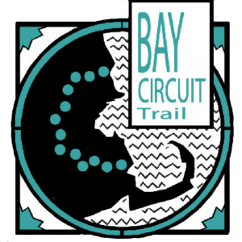
BCT Bike Challenge Completion Guidelines

The rules of the challenge are simple! The challenge is based on a point system. In order to earn 100 or 200 points to complete the challenge and receive your prize, either bike 100 or 200 miles on the BCT or design your own challenge by completing several alternative activities listed below. Sign up for the challenge to secure an opportunity to earn a new BCT patch!

Point Earning Activities:
For 1 point per mile:
- Bike

Alternative Earning Activities
- Volunteer with us on the trail – 3 points/hour
- Attend an AMC sponsored hike or ride on the BCT – 2 points/event
- Attend a hike or ride on the BCT sponsored by a different organization or group – 2 points/event
- Tag us in your BCT social media posts #BCT #BayCircuitTrail #BCTBikeChallenge – 1 point/post

FAQ

Do the miles have to be unique miles?
No they don’t! We want this challenge to fit your life as best as possible and encourage people to get on the trail! If someone bikes the same 5 miles over and over, equal to 50, that will count. If you are tracking your miles and you don’t hit a round number, just round up or down to the nearest whole point i.e. 1.3 miles = 1 point, 1.6 miles = 2 points
Do I have to sign up for the challenge to receive the patch?
The signup for this challenge is open to 200 people, since we only have 200 patches to send out at the end of the year. The signup link will close when we’ve reached 200 participants. If you complete the Bike 100 or 200, your chances of receiving a patch are much higher if you register in advance! You can still notify us that you completed the challenge even if you did not sign up, but a patch is not guaranteed.

Can my kids or dog get a patch?
Your kids can absolutely get a patch. There is no age limit! Every member of your family who bikes 100 or 200 miles or earns 100 or 200 points on the Bay Circuit Trail in 2025 is eligible to earn a patch. As much as we love your dogs, the patch is only for people.
How can I track my miles, activities, and points?
There is no right or wrong way to track your progress. Whether you use our log sheet, create a spreadsheet, use an app, or write them in a notebook we are just happy that you are joining us on the trail!

Does the challenge cost any money?
No! This challenge is free thanks to donations from generous supporters! However, there is a participant limit of 200 people due to a limited supply of patches. The signup for this challenge will close when this number is reached.

If I have more questions who can I contact?
Didn’t find what you were looking for here? Feel free to reach out to us via email and we will be happy to answer your BCT Bike Challenge related questions

